Setup & Firmware Uploading Guide
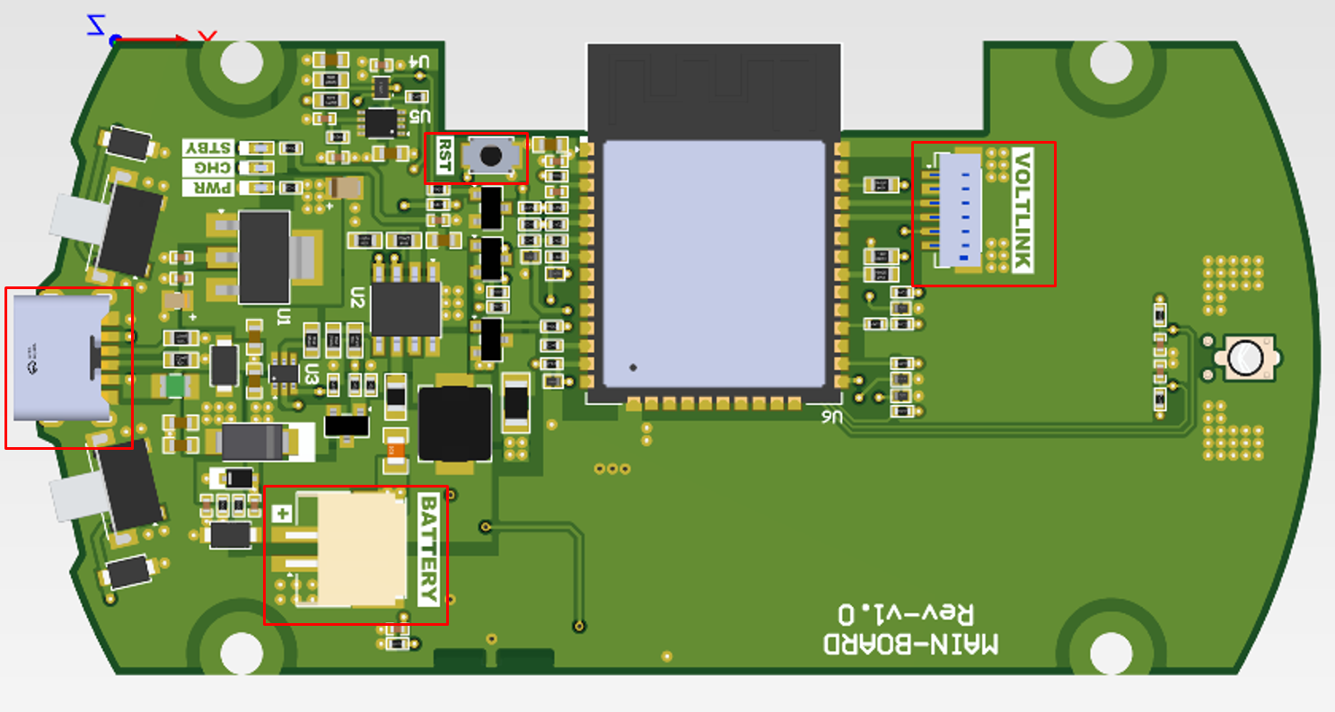
Figure: 1

As shown in the Fig: 1, there is one connector available for Voltlink interface.
“Connector Named Voltlink” is intended for Firmware Flashing.
Switch Labeled “RST” is Reset Switch as shown on above figure
Type C Connector is Provided for Power and Charging the Battery (5V DC)
Battery Connector is Present for Connecting internal Battery, It is Labeled as “BATTERY” the Plus Sign “+” indicates Positive terminal of the battery (4.2VDC Max).

Hardware Setup:
Connect Voltlink with Main-Board PCB, as illustrated in Figure: 2, Use the connection cable provided with the Voltlink adapter to connect “J1” from Voltlink PCB with “VOLTLINK” on Main-Board PCB.
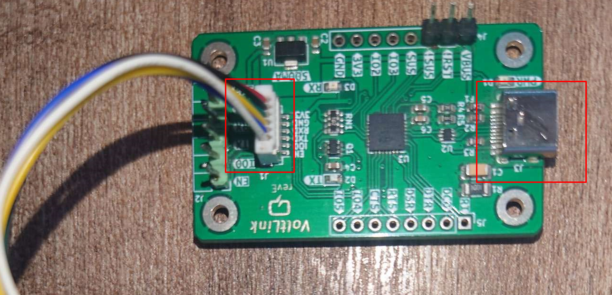
Figure: 2
Make sure both Boards are placed on an insulated surface before powering the boards.
Connect Type C connector for Main-Board first, and Connect Type-C cable with Voltlink Board and PC.
Power ON the main Board and make sure the LED D1 placed near Type-C connector on Voltlink Board is glowing. After powering on proceed to the next step.

Set up development environment:
Step 1. Install the Serial port:
Make sure the Voltlink-board is connected to computer via Type-C USB.
After connected, the USB driver will be automatically installed. If there is any driver issue of connecting board, please go to CP210x USB to UART Bridge VCP Drivers - Silicon Labs for USB driver. Check the COM Port number in Device Manager for Windows OS user:
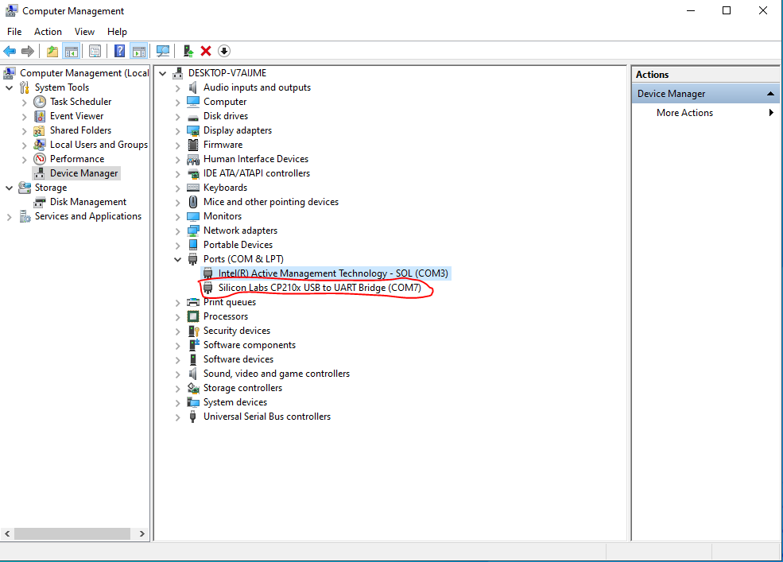
Step 2. Install the required Software:
Download and install the software from the Following Link:
https://dl.espressif.com/public/flash_download_tool.zip

Firmware Download Procedure:
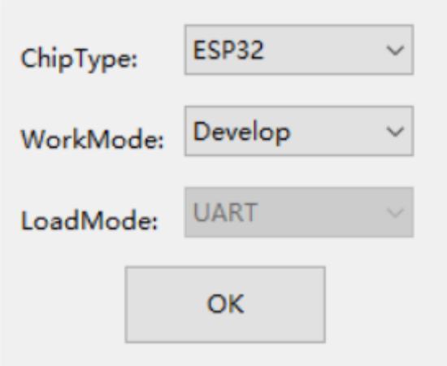

Open flash download tool and select Chip Type as ESP32 and WorkMode as Develop. Press OK to move to the next screen.

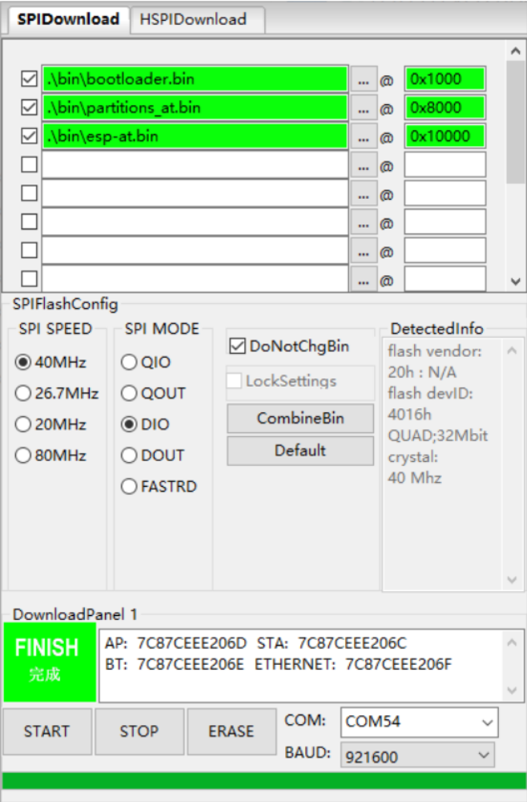

Select correct COM Port and set Baud rate to 921600 and then click erase button on new window that opens, to first completely wipe off the ESP32 memory.

Upload the provided binaries as follows:
Test.bootloader.bin -> 0x1000
Test.partitions.bin -> 0x8000
Test.ino.bin OR -> 0x10000
Press the start button to start the flashing process

